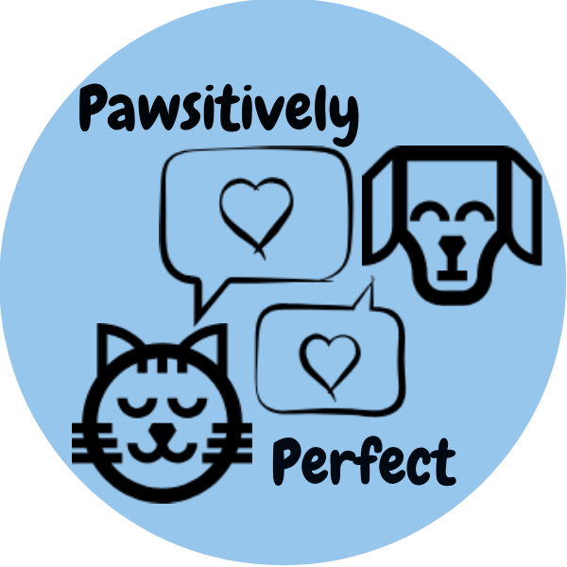

“You can’t buy love, but you can rescue it!”

Campaign Proposal for Animal Rescue & Adoption

Dominique Hammond & Jourdan Kania
COM 5130 Winter 2019
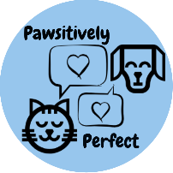
Pawsitively Perfect
14575 Garfield Rd.
Clinton Twp, MI 48038
Dr. Jane Fitzgibbon
Wayne State University
42 W. Warren
Detroit, MI 48202
April 18th, 2019
Dear Dr. Fitzgibbon,
On behalf of Pawsitively Perfect, we submit for your review a proposal to encourage pet adoptions in the Midwest region, as well as put a stop to the inhumane practice of puppy mills and animal breeding.
Millions of animals in shelters across the United States are euthanized each year due to overcrowding. This continues to go on and still 34% of Americans are purchasing their animals, either from breeders or pet stores who source from dangerous puppy mills. Our campaign hopes to enlighten potential pet owners to the joy of rescuing an animal, as well as to help them see that their one act of saving an animal’s life could have an impact on the very existence of cruel practices against cats and dogs.
As you review this proposal, you will see the statistics on pet adoption in America and the potential that pet owners could have to decide the future of the puppy mill industry. You will see the established organizations that sponsor the initiative and/or have partnered with Pawsitively Perfect. We present a thorough analysis of the strengths and weaknesses of our campaign, as well as potential barriers to our success, to which we have presented solutions. You will be able to review our objectives in detail, as well as a detailed marketing plan and budget for the campaign.
The actions encouraged by this initiative have the potential to shape the future of animal adoption, and help to end the existence of cruel puppy mills and breeding. We hope that you carefully review and consider this proposal, and decide to lend us your support in order to make this possible. We very much appreciate your time and willingness to review our proposal.
Sincerely,

Dominique Hammond & Jourdan Kania
Pawsitively Perfect

Index

Executive Summary . . . . . . . . . . . . . . . . . . . . . 2
Background & Need . . . . . . . . . . . . . . . . . . . . . 3
Goals & Objectives . . . . . . . . . . . . . . . . . . . . . 4
Analysis . . . . . . . . . . . . . . . . . . . . . . . . . . . . 5
Barriers . . . . . . . . . . . . . . . . . . . . . . . . . . . . 7
Marketing . . . . . . . . . . . . . . . . . . . . . . . . . . 8
Budget . . . . . . . . . . . . . . . . . . . . . . . . . . . . 10
Implementation Plan . . . . . . . . . . . . . . . . . . . . 11
Evaluation Plan . . . . . . . . . . . . . . . . . . . . . . . 12
Next Steps . . . . . . . . . . . . . . . . . . . . . . . . . . 13
Appendices . . . . . . . . . . . . . . . . . . . . . . . . . 14

Executive Summary
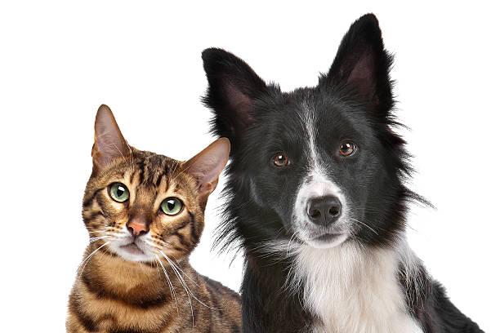
Pawsitively Perfect aims to not only help place shelter animals into their perfect homes, but also to educate the public about the plight of puppy mills and dismantle them.
Our Goals:
- Encourage families and individuals seeking an animal companion that adoption is the best option.
- Increase awareness of the cruel conditions that exist at puppy mills.
- Decrease the amount of puppy mills in our region.
- Alter the public misconception that animals from a breeder or pet store are more desirable than animals from shelters.
The overall purpose of our campaign is to increase the number of pet adoptions from shelters as opposed to breeders. By encouraging potential pet owners to adopt animals rather than purchase them from a breeder or pet store, it will help to reduce the number of animals currently sitting in shelters. A positive byproduct of achieving this goal would be the reduction in the profitability of puppy mills and breeders, which would over time encourage the closure of cruel breeding facilities and prevent the existence of these harmful environments.
The campaign will span the course of three years and will include an aggressive social media presence, regular adoption events and evaluations to be done at yearly intervals which will measure success. We have acquired multiple partnerships and sponsorships already, including those with Boehringer-Ingelheim, Purina, Petco, Pet Supplies Plus and Animal Clinic of Sterling Heights, as well as the Humane Society of the United States, the Detroit Animal Welfare Group (DAWG) and Detroit Dog Rescue (DDR).
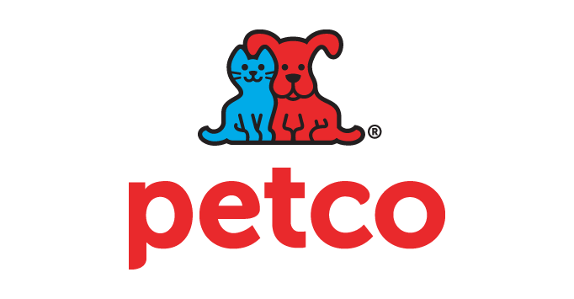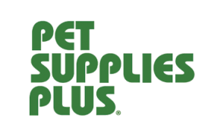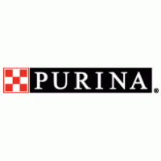
Background & Need
According to statistics from the ASPCA and The Humane Society of the United States, an estimated 3 million animals are euthanized in shelters each year. Of these animals, around 80% were considered healthy and adoptable.
According to these same statistics, 34% of Americans still purchase their animals from a breeder. Dog breeding, and commercial dog breeding such as the kind that occurs in puppy mills, not only contributes to the already rampant overpopulation of domestic animals in the U.S. but also results in less incentive to adopt a shelter animal who might otherwise be killed.
Conditions at puppy mills are inhumane and unsanitary (see Appendix B for additional photos of puppy mill conditions); puppies are often taken from their mothers too early which results in behavioral and medical problems that cause their owners to abandon them at shelters – approximately 25% of animals brought into shelters are purebred.
In multiple ways, the continued existence of dog breeding, both commercial and otherwise, contributes to the death of shelter animals. Pawsitively Perfect sees every animal bought as equivalent to an animal that is not rescued.

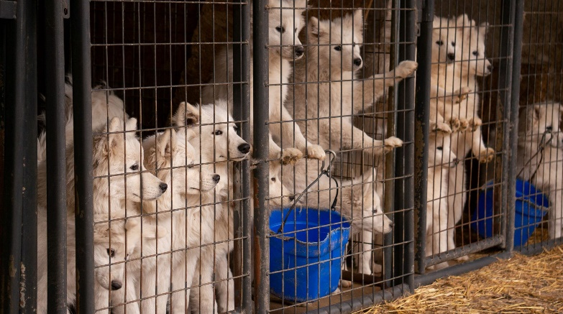
Puppies rescued from a puppy mill in Iowa, November 2018
Pawsitively Perfect aims to address the very immediate problem of animals who are in need of homes, but also the root cause of many animals’ suffering: puppy mills and breeding.
Goals & Objectives
- Increase the number of animals adopted from shelters or rescues while also decreasing the number of animals purchased through breeders or from pet stores.
Our target audience will be helping save the lives of animals who might otherwise be euthanized, while also siphoning business from animal breeders and pet stores.
- Change perceptions of what a rescue animal is.
Many people still hold beliefs that rescue animals have health or behavioral problems, while animals that are bred have fewer of the same issues. Our campaign would aim to debunk these myths and actually educate our target audience on the behavioral and health risks that result from animals being bred in puppy mills.
- End the existence of puppy mills.
When an animal is rescued, it is one less animal purchased from a pet store or animal breeder. By boycotting stores that source from these establishments, our campaign hopes to make puppy mills far less profitable and force them into closure.

Analysis
- Strengths:
  - Resources/Current Alliances & Sponsors – our campaign has multiple partnerships and sponsors that we will use as a resource
    - Purina
    - The Humane Society of the United States
    - The Michigan Humane Society
    - Pet Supplies Plus
    - Petco
    - Boehringer-Ingelheim
    - Detroit Animal Welfare Group (DAWG)
    - Detroit Dog Rescue (DDR)
  - Channels
    - Both the Humane Society of the US and the Michigan Humane Society have large social media followings via Facebook, Instagram, and Twitter.
      - We will take advantage of these channels while also using them to help grow our own social media following.
  - Past Performance
    - The Humane Society continues the fight to educate current and future pet owners about puppy mills and ways to stop them.
    - Rescue organizations such as DAWG and DDR are also fighting to rescue abandoned and stray animals and find homes for them.
    - A similar LA-based group called Last Chance for Animals led a similar effort in 2007 and were quite successful.
      - Coined phrase “Adopt! Don’t Shop.”
      - Forced the closure of multiple pet stores in the LA-area who sourced from puppy mills.
- Weaknesses:
  - Issue Priority
    - The Humane Society, DAWG and DDR’s sponsors also support and sponsor other animal welfare campaign. This could result in future issues with funding and donations.
- Opportunities:
  - External publics
    - Many local animal rescue organizations exist around the Detroit area, already with huge social media followings, donors, and mailing lists. Having these organizations as external publics would be a great opportunity for our campaign to gain access to a wider audience.
  - Cultural Opportunities
    - Pop culture: Adopting animals and the plight of puppy mills has become a hot topic of conversation in American culture over the last few years.
      - Blogs and even more mainstream publications such as Rolling Stone magazine have published articles exposing the conditions of puppy mills.
      - Having this topic fresh in the minds of our target audience would help to make them more receptive to our messages.
  - Technological opportunities
    - Social media: nearly every American now carries cell phones, meaning they have constant internet access. Our campaign would take advantage of this opportunity by enhancing our social media presence and using it to spread the many reasons why adopting is a better option for potential pet owners.
  - Demographic opportunities
    - The millennial demographic: Statistically, millennials now represent the majority of pet owners in the country. With the millennial tendency toward social media and technology, we could easily use the opportunities listed above to persuade millennials of the virtues of adopting animals versus shopping for them.
  - Economic opportunities
    - Millennial buying power: Pet ownership, including veterinary bills, food, etc., can be expensive and likely would not be considered by those unable to afford the care that an animal entails. But with increased buying power, the millennial generation (the oldest nearing their mid-30s and the youngest just reaching their 20s) would potentially be more interested in pet ownership.
- Threats:
  - Legal threats
    - Avoiding lawsuits: Unfortunately, puppy mills are not an illegal practice. Because of this, our campaign must be careful not to directly threaten the livelihood of those who make money from owning or operating these places.
    - Great care must be taken only to encourage our target audience to change their behavior from shopping to adopting, passively taking profitability from these organizations, and not to encourage them to take any physical action against them.

Barriers
Potential Barriers | Solution
Target audience may not live within close proximity to shelters. | Feature adoptable animals on our social media channels, as well as holding adoption events in various locations around the region in order to make the animals more accessible.
Target audience may not want to go through an application phase to adopt. | Help potential adopters to understand that an application phase is necessary for the well-being of the animals being adopted. We would also offer a guarantee that the process would never take longer than 7 days.
Target audience has a lack of knowledge as to the conditions of puppy mills and how it could affect their potential future animal. | Frequently post educational blogs to our social media channels to help educate on the conditions of puppy mills and how it affects health and behavior of the animals raised there.
Target audience feels that their one moment of action will not have the potential to affect real change. | Frequently post motivational and educational blogs that show how historically the actions of groups of people boycotting an industry has affected real change.
Target audience feels they will be unable to find the breed of animal they want at a shelter or rescue. | We will use hashtags on our adoptable animal posts for rare or highly-sought after breeds in order to help people more easily locate what they want.
Target audience feels that shelter or rescue animals are “too much work”. | Frequently post educational blogs to our social media channels that illustrate the behavioral and health problems that result from puppy mill animals, as well as success stories of families or individuals who adopted from shelters.

Marketing
Product Platform: Adopting an animal from a shelter or rescue is more cost effective than purchasing from a breeder or pet store, as well as being a more rewarding experience.
Promotion Strategy: Our campaign will utilize influencers, such as midstream audiences (family, friends, neighbors) close to our target audience, volunteers, and social media channels, to convey our key messages:
- When you adopt an animal, you are saving a life.
- Your one adoption does make a difference in the fight against commercial breeding and puppy mills.
- Adopting an animal is more fulfilling and rewarding than purchasing an animal from a store or breeder.
- Shelter and rescue animals are just as worthy as animals that were selectively bred.
- When you adopt an animal, you will feel good about what you have done and you will have affected and inspired change.
We would also utilize other communication channels, such press releases detailing adoption events, and flyers/posters posted and distributed to local veterinarians, pet supply stores and dog parks. In addition, we would utilize local radio mentions, inviting local DJs to broadcast from the site of an adoption event for the morning/afternoon.
Place Strategy: One of the key strategies of our campaign are the adoption events held twice a month. These events would be held at different pet supply stores whom we are partnered with, and would feature animals from different shelters or rescues. The events would be heavily promoted via campaign social media channels, as well as promotion by the pet supply store hosting the event.
- Potential adopters would be encouraged, via social media channels, to submit an application prior to the date of the adoption event in order to lessen the waiting period.
  - If they were to decide not to adopt an animal that day, application would be kept on file for potential future adoptions.
- Locations of the adoption events will vary with each week to make adoptable animals more accessible to people in different areas.
  - Potential adopters will also be able to reach out via social media and request to meet a certain animal they may be interested in when an event is held in their area. Arrangements would be made to accommodate that.
Price Strategy: Adopters would be asked to pay an adoption fee (this will vary between different shelters and rescues) but would greatly benefit from the adoption kits provided by our campaign.
- Adoption kits will come in a drawstring bag adorned with the Pawsitively Perfect logo. Included in adoption kits:
  - Tag
  - Leash
  - Collar
  - Bag of dog food
  - Logo T-shirt
  - Food dishes
  - Lid for pet food can (with logo)
  - Coupon for dog wash from local groomer
  - First dose of Heartgard™ heartworm prevention, as well as a coupon to purchase the next dose from a local veterinarian
- Shelter animals cannot be adopted out if they do not meet certain standards of health.
  - Adopters can be assured that there are no hidden health problems at the time of adoption, saving on potentially expensive vet bills.
  - All animals will be spayed/neutered, and up-to-date on all age appropriate vaccinations, saving the new owner a great deal of money.
- Nonmonetary incentives would include a personalized post on our social media channels featuring a picture of the pet and its new owner(s), celebrating the adoption of the animal.
Budget
The estimated budget for Pawsitively Perfect is $438,432 for a campaign that will span just over three years. This includes regular adoption events to be held twice a month for the duration of the campaign. Boehringer-Ingelheim, the makers of Heartgard™ heartworm prevention medication, have agreed to provide the campaign with free samples as well as manufacturer’s coupons to be included in all adoption kits in exchange for the promotion of their brand. See Appendix A for examples of our promotional items.

Implementation Plan
The phases of our campaign will be organized by a combination of our short- and long-term goals and objectives.
- Phase 1 – Most Immediate Objective
- Objective: Get target audience to adopt an animal from a shelter rather than purchasing from pet store or breeder.
- Goal: reduce the number of animals purchased (from pet stores/breeders) by 25% by the year 2021.
- Phase 2 – What Our Campaign Wishes to Accomplish Given More Time
- Objective: Drive puppy mills (and the pet stores who source from them) out of business by convincing target audience to boycott them.
- Goal: reduce the amount of puppy mills in the Midwest region by 50% by the year 2022.
- Phase 3 – Long-term Goals of our Campaign
- Objective: Convince any remaining pet stores that it would be in their best interests to work with rescues/shelters and source animals from them rather than breeders or mills.
- Goal: further reduce the amount of puppy mills in the Midwest region by 25% by the year 2023.

Refer to Appendix C for a more detailed description

Evaluation Plan
The success of our campaign will ultimately be evaluated in three ways.
- Successful adoptions resulting from our events and campaign will be calculated using records of adoption applications and agreements.
- Secondarily, we will include a survey on receipts from certain veterinarians and pet supply stores to ascertain the breadth of our campaign. Refer to Appendix D for a sample survey.
  - We will further utilize these surveys to educate those who indicate they haven’t heard of Pawsitively Perfect about our campaign.
  - This survey will also evaluate the likelihood that the participant would rescue an animal rather than purchasing, thereby measuring attitudes and perceptions toward animal adoption.
- The existence of puppy mills is a notoriously difficult number to measure, as these organizations are very seldom honest about what they do nor are they likely to promote their existence.
  - We would rely on numbers from larger organizations, such as the Humane Society or ASPCA, to calculate our impact on puppy mills.
Next Steps
Once our campaign proves to be successful, we hope to expand outside of the Midwest and take the campaign national. We would continue the fight against puppy mills and breeding, while still holding regular adoption events and promoting the idea that even a seemingly small action can have a huge impact.
Appendices
Appendix A – promotional items
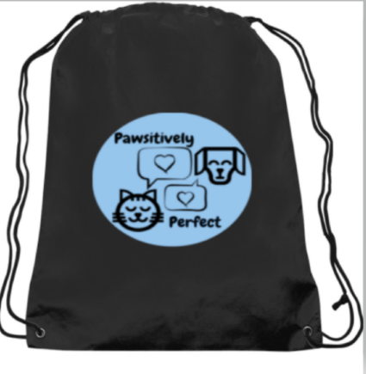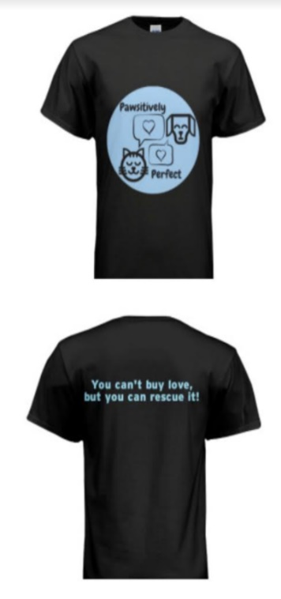
Drawstring bags w/ logo Logo t-shirts front & back

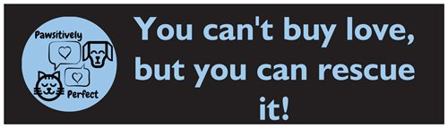
Bumper sticker
Appendix B – photos of the conditions of puppy mills across the U.S.
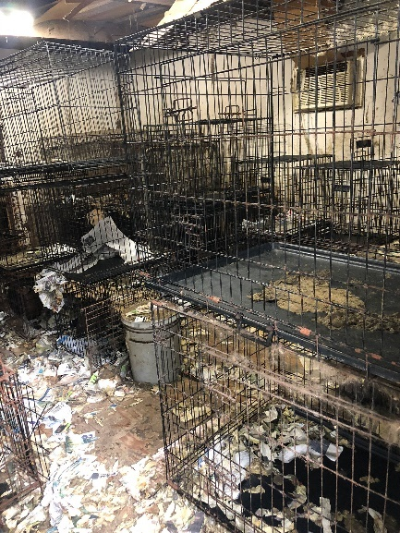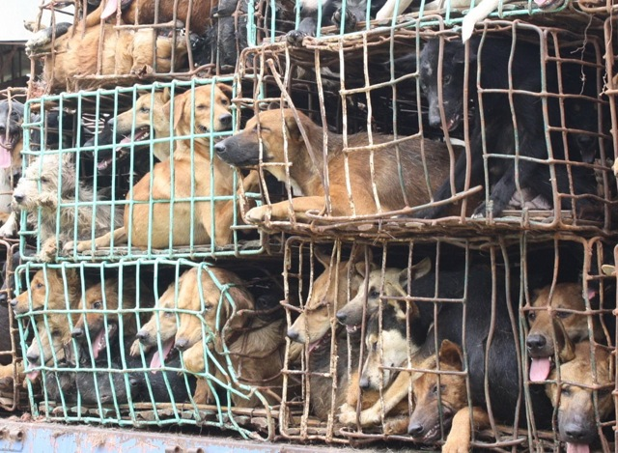
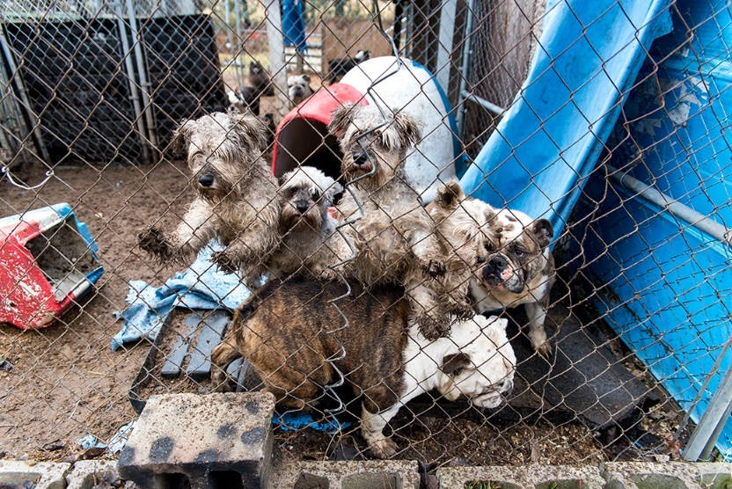
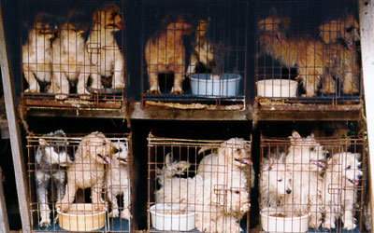
Appendix C – full details of implementation plan
Phase 1
- 3 months prior to first adoption event
  - Dominique Hammond will create social media pages for the campaign, including Twitter, Instagram and Facebook.
    - Using the social media connections, we will solicit donations in order to fund the adoption events as well as recruit volunteers to work them.
    - She will follow/add/interact with local rescues and animal activist groups.
    - Over the course of the next three months, she will write and post short blogs about the conditions of puppy mills, and how our target audience can help end it, in order to generate a buzz.
  - Jourdan Kania will speak with local pet supply stores such as Petsmart, Pet Supplies Plus, and Petco in order to secure a venue for the adoption events.
    - Dates for the events will be secured at each venue.
      - Once dates are final, Facebook event pages will be made to promote each adoption event.
    - She will use the social media connection already made to contact local rescues and shelters who may also want to participate in these events.
  - Dominique Hammond will approach local groomers and veterinarians to donate coupons/receipt survey coupons in exchange for free advertisement.
- 1 month prior to first adoption event
  - Using donations acquired via social media campaigning, purchase the items that will be included in adoption kits (logoed t-shirts, food dishes, food, collars, leashes and tags)
    - Handled by Jourdan Kania
  - Purchase promotion-related items (press release, flyers and posters)
    - Hang posters in the store where our first event will be held to increase awareness of the event
    - Handled by Dominique Hammond
  - Assemble adoption kits for first adoption event
    - Handled by Jourdan Kania and volunteers
  - Begin more aggressively advertising the event via social media and physical flyers at local pet supply shops, veterinarians and groomers
    - Handled by Dominique Hammond and volunteers
- Day before first adoption event
  - Purchase refreshments for event
    - Handled by Jourdan Kania
  - Secure transportation for animals/volunteers to and from adoption event
    - Handled by Dominique Hammond
  - Print adoption applications to be used at event
- Day of adoption event
  - Evaluate turnout and calculate successful adoptions or applications to adopt completed during the event
    - Record these numbers to be evaluated in conjunction with other adoption events in the future.
    - Handled by Jourdan Kania and Dominique Hammond
- These events will continue for the duration of our campaign much in the same way, gaining more public attention and attendance as time goes on.
  - In the year 2021, we will evaluate the numbers and see if our campaign was successful in its goal of reducing the number of animals purchased by 25%.
Phase 2
- Phase 1 will roll over and continue as we move into Phase 2.
- Two adoption events per month.
- Using our increased attention from the public, driven by the success of our adoption events, we will draw more attention to puppy mills and the need to drive them out of business.
- Our target audience will see their adoption of an animal as an act of boycott against puppy mills/the pet stores who source from them.
- This will be done via social media and our events.
- Handled by Dominique Hammond, Jourdan Kania and volunteers.
- Research and assess the amount of puppy mills still operating in the Midwest region by 2022, to see if our campaign reached its goal of reducing the amount by 50%.
- We will present our findings to national organizations such as the ASPCA and the Humane Society.
- Handled by Dominique Hammond and Jourdan Kania
Phase 3
- Phases 1 and 2 will roll over into continue as we move into Phase 3.
- Two adoption events per month.
- If our campaign finds success in its reduction of the amount of puppy mills, we will approach local pet stores who source from them.
- We will present our research and data to show them it would be more lucrative to partner with our shelters and rescues to source animals from.
- We will leverage our position in order to offer them free advertising at our adoption events and an incentive per animal that they source from shelters
- $75 per animal, plus our campaign would pay for the care of the animal until they are adopted.
- This will help to prevent puppy mills from receiving financial support of any kind, thus driving them out of business.
- Handled by Dominique Hammond and Jourdan Kania.
- Further assess in year 2023 the reduction in the amount of puppy mills in the Midwest region, which we had hoped to reduce by another 25%.
- We will present our findings to national organizations such as the ASPCA and the Humane Society.
- Handled by Dominique Hammond and Jourdan Kania.

Appendix D – a sample survey receipt
Pet Supplies Plus
Address
XXX-XXX--XXXX

Item:
XXXXXXXXXXXXX $X.XX

Subtotal $X.XX
Taxable Amount $X.XX
Non-Taxable Amount $X.XX

TOTAL $X.XX

We want your feedback!
Receive 10% off your next visit when you complete our online survey.
Visit xxxxxxx.com and complete survey within 7 days.
Thank You

Animal Clinic of Sterling Heights
Address
XXX-XXX-XXXX

Item:
XXXXXXXXXXXXX $X.XX

Subtotal $X.XX
Taxable Amount $X.XX
Non-Taxable Amount $X.XX

TOTAL $X.XX
We want your feedback!
Receive 10% off your next visit when you complete our online survey.
Visit xxxxxxx.com and complete survey within 7 days.
Thank You

Online survey questions:
Have you heard of Pawsitively Perfect’s Campaign?
Yes No
◌ ◌
(If no, a brief summary of the campaign will appear.)

After hearing about Pawsitively Perfect’s campaign, how likely are you to adopt a future pet from a pet shelter rather than a breeder or pet store?
Very unlikely 1 2 3 4 5 Very likely
◌ ◌ ◌ ◌ ◌

